

JUNIOR CHAMBER INTERNATIONAL PHILIPPINES
Worldwide Federation of Young Leaders and Entrepreneurs
PHILIPPINE JAYCEES, INC.
A Worldwide Leadership Development Organization
14 Don A. Roces Ave., Quezon City
Tel. 373-79-7 to 09 Fax 374-41238
E-mail : NOM@philjaycees.com Website: www.philjaycees.com

JCI MAXX DISCOUNT AGREEMENT
(Maximum Action Card System)

The ________________________________, with mailing address at______________________, hereby agrees to be an affiliate member-ESTABLISHMENT of the ‘JCI MAX’ and hereby mutually abide by the terms and conditions stipulated in this Agreement to grant the discount/s on the retail tag price and regular rates on specific products and services to bonafide members of the JCI Philippines:

Items/Services Percentage / Discount
______________________________________ _____________________________
______________________________________ _____________________________
______________________________________ _____________________________

Please refer to Annex A.1 for all other Items/Products/Services.

- AVAILABILITY OF DISCOUNTS: The discount shall be available at the following outlets:

Outlet Address
___________________________________ _______________________________
___________________________________ _______________________________

Please refer to Exhibit A.2 for other outlets.

- PAYMENTS: Discounted rate shall be granted on the following modes of payment:
Spot Cash ________% Credit Card ________%

3.0 EXCLUSIVITY: All items (for sale) are covered by discount.
All sales and promotional items are not covered by discount.

4.0 PROMOTIONS and REPRESENTATION: The JCI MAX stickers shall be prominently displayed in all entrances and exits of the establishment and at the cashier’s counter. Sticker shall be provided by the Jaycees free of charge. The Jaycees shall promote the establishment by circulating a list of accredited business establishments to all the JCI members nationwide.

5.0 SPECIAL COMPANY POLICIES: The Jaycees shall abide by the establishment’s
policies on discount privileges, provided that purchaser/buyer agrees on said special policies which have been agreed upon prior to the sales transaction.

6.0 VALIDITY: Unless either party signifies intent of renewal at least two months before said expiration date, the validity of this Agreement shall be until:

January 1, 2006 December 31, 200__

The ESTABLISHMENT and JCI PHILIPPINES hereby signify their full understanding and conformity to the TERMS and CONDITION of this DISCOUNT AGREEMENT by affixing their signatures this_____day of_________________, 2006.

ESTABLISHMENT JCI PHILIPPINES
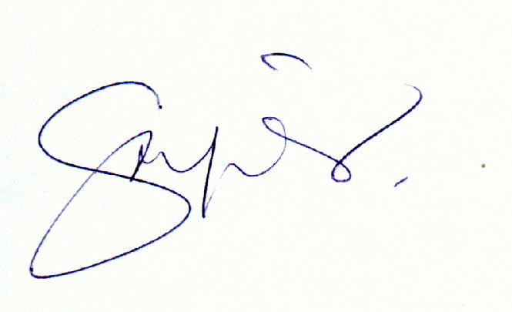

_____________________________ __________________________
Printed Name/ Signature JCI Sen. ISMAEL P. PENADO
National President
____________________________
Designation
Witnesseth
______________________________ ________________________________
Signature Over Printed Name LOM Representative

